mezzònomy Business Plan

1 Mezzònomy Value Proposition 1

2 Opening the way to the blockchain democratization 1

3 Mezzònomy key differentiators 2

3.1 Bring the power of blockchain to your web services 2

3.2 Fully W3C compliant blockchain platform 3

4 Mezzònomy RnD roadmap 3

4.1 Product Roadmap 3

4.2 RnD Effort 3

5 Market analysis 4

5.1 Areas of investment 4

5.2 Analysis of investment - categorization 4

5.3 Analysis of investment – investment map 5

5.4 mezzònomy positioning 5

5.5 Market maturity 5

6 Mezzònomy markets 6

7 Mezzònomy GO TO markets 6

7.1 Sales Growth 6

# Mezzònomy Value Proposition

Mezzònomy has developed a full proofed blockchain technology which is an alternative to the Bitcoin technology and can be deployed as a private blockchain in any organization which needs to deploy the blockchain to deliver breakthrough applications.

Mezzònomy provides better levels of security than the Ethereum technology which has now evolved in two competing standards since its forking.

The Mezzònomy technology is very simple to deploy as it is fully W3C compliant and thus can be mastered by widely available programming resources as it only requires W3C programming skills: XML, XSL, HTML, CSS.

# Opening the way to the blockchain democratization

Blockchain systems allow their information ecosystem to deal with time, proof and security with unique and disruptive capacities.

mezzònomy’s hypertext is a fully W3C compliant blockchain platform able bring to its customers both the capacities of blockchain and the capacities of web services. In mezzònomy’s technology,

* any blockchain node is also a web server which can be accessed by a great number of users through any web navigator. Mezzononomy is already fully usable using Chrome, Firefox or IE.
* any user feedback is a potential coin, with mezzònomy any web page permits to add theses coins to the distributed ledger according to the position and the intent of the user.
* any elaboration of contents and its associated monetization and diffusion control, both in space and time, can be addressed by the technology.

# Mezzònomy key differentiators

## Bring the power of blockchain to your web services

No expert programming skills are required when deploying a mezzònomy blockchain – contrary to blockchain applications built on top of Bitcoin, Ethereum and HyperLedger technologies.

With common resources able to deal with W3C standards used in existing web services, the power of the blockchain can be brought to any web service, with massive reuse of your existing digital assets.

## Fully W3C compliant blockchain platform

Since its foundation in 2008, the mezzònomy paradigm relies on the W3C programming: XML, XSL, HTML, CSS. The fundamental facts over this technology are:

* To give access to the blockchain world in this W3C context, mezzònomy provides a tag to manage time hyperlinks and an attribute to manage space hyperlinks – any hyperlink being bidirectional and “*can be followed from all endpoints*”.
* Any user feedback is coined as set of XML elements, with a given number of time hyperlinks and a given number of space hyperlinks.
* Any application is an XSL, managing both the blockchain verification and the dynamic HTML/CSS web page for a given user position, intention and behavior.

# Mezzònomy RnD roadmap

## Product Roadmap

Mezzònomy plan to provide a set of:

* Development tools
* Administration & supervision

In 3 stages described as follows:

|  |  |  |
| --- | --- | --- |
| **Offering** | **Development** | **Administration & supervision** |
| Lite | N/A (**GitHub**) | **Wizard** |
| Regular | **Composer** | **Architect** |
| Full | **Forge** | **–** |

# Market analysis

The investment in blockchain companies had grown 232% from 2012 to 2016: the total amount of blockchain investments accounts for 497 MUS$ in 2016 (source CoinDesk).

## Areas of investment

Investments are done mainly in the financial area for applications like:

* Finance
* Crowd funding
* Mobile payments
* Money transfer
* Money flow management

## Analysis of investment - categorization

We analyzed the many investments in the BlockChain Area and we categorized the companies as follows:

* « Blockchain » Evangelist
* [bitcoin | ethereum | alternative | independant] **CC Trading**
* [bitcoin | ethereum | alternative | independant] **CC Wallet**
* [bitcoin | ethereum | alternative | independant] **CC API**
* **Payment system** « in real money »
* **Big Data** « analysis and mining »
* **Content certification**
* **Peer-to-peer Cloud**
* **Ecosystem builder**

## Analysis of investment – investment map

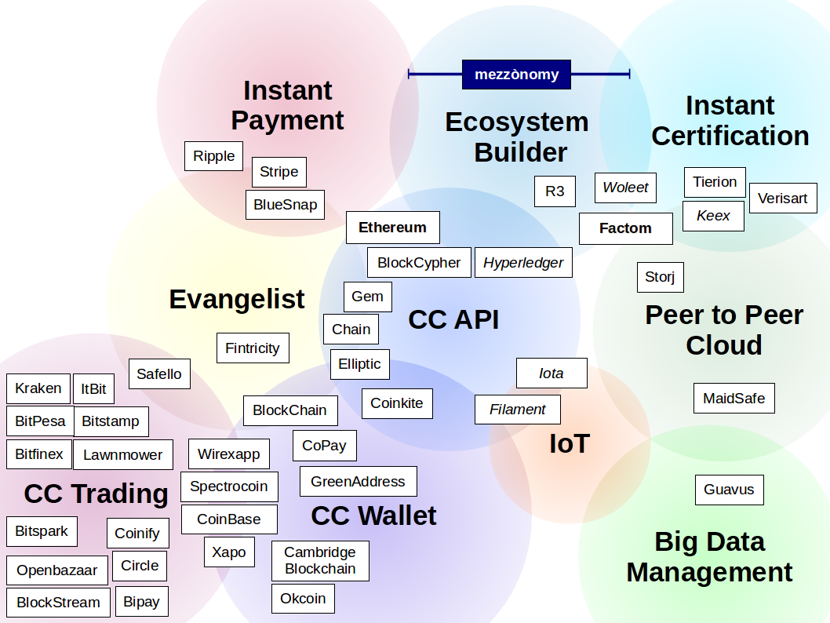

## mezzònomy positioning

Our view of the mezzònomy positioning is as an **Ecosystem Builder**, with a distinctive economic model based on an embedded **Payment System** and dedicated to **Content Certification**.

## Market maturity

The two main factors slowing the growth of the blockchain development are:

1. The lack of market education both on the business side and technical side
2. The lack of market standard for the public blockchain

# Mezzònomy markets

Mezzonomy will address primarily markets which involves a lot of “reconciliation” processes and decentralized high value document sharing.

These markets are:

* The logistic market
* The e-health market
* The audit market
* The engineering market

# Mezzònomy GO TO markets

The GO TO market will be executed by a viral approach of the market which will go thru:

* The blockchain ecosystems in the key geographies:
  + Europe
  + The US East Coast
  + South East Asia
* The System integrators in the key geographies
* A set of industry Proof of Concepts in some of the key industries

## Sales Growth

The Sales growth will be sustained by a strong ecosystem effort will rely heavily on the creation of an ecosystem whose task is to enroll companies in using the mezzònomy technology.

|  |  |  |  |  |  |
| --- | --- | --- | --- | --- | --- |
|  | **2017** | **2018** | **2019** | **2020** | **2021** |
| Operating Income (in K€) | 142 800 | 1 392 300 | 4 207 500 | 16 780 500 | 102 170 700 |
| Pre-Sales FTEs | 0 | 1 | 3 | 6 | 8 |
| Partnership FTEs | 0 | 8 | 11 | 12 | 12 |
| Industry verticals FTEs | 0 | 4 | 4 | 4 | 4 |

The team will also include Industry specialistq whose role is to develop and animate offerings which are specifically targeting the key markets: logistic, e-health, audit and engineering.